Software Requirements Specification

for

LIBRARY MANAGEMENT SYSTEM

Version 1.0 approved

Prepared by :

MOHAMMAD SAYEED AKRAM : PES2UG20CS201

RAGHAVENDRA M KATAGERI : PES2UG20CS261

NAMAN PANDE : PES2UG20CS210

PARTH PRAVEEN SHETTY : PES2UG20CS240

PES UNIVERSITY

28-09-2022

Table of Contents

Table of Contents ii

Revision History ii

1. Introduction 1

1.1 Purpose 1

1.2 Intended Audience and Reading Suggestions 1

1.3 Product Scope 1

1.4 References 1

2. Overall Description 2

2.1 Product Perspective 2

2.2 Product Functions 2

2.3 User Classes and Characteristics 2

2.4 Operating Environment 2

2.5 Design and Implementation Constraints 2

2.6 Assumptions and Dependencies 3

3. External Interface Requirements 3

3.1 User Interfaces 3

3.2 Software Interfaces 3

3.3 Communications Interfaces 3

**4. Analysis Models**

5. System Features 4

5.1 System Feature 1 4

5.2 System Feature 2 (and so on) 4

6. Other Nonfunctional Requirements 4

6.1 Performance Requirements 4

6.2 Safety Requirements 5

6.3 Security Requirements 5

6.4 Software Quality Attributes 5

6.5 Business Rules 5

7. Other Requirements 5

Appendix A: Glossary 5

Appendix B: Field Layouts 5

Appendix C: Requirement Traceability matrix 6

Revision History

|  |  |  |  |
| --- | --- | --- | --- |
| **Name** | **Date** | **Reason For Changes** | **Version** |
|  |  |  |  |
|  |  |  |  |

# Introduction

## Purpose

The purpose of this Library management system project is to provide a friendly environment to maintain the details of books and library members (students). Since it’s a difficult job for a Admin to physically maintain all student and book records, this LMS plays an important and an useful role.

## Intended Audience

The Intended Audience of this project are:

1. Educational Institutions – since they have a large number of students who’s records are to be maintained in library book transactions.
2. Developers will get an idea of LMS so that they can implement similar projects by referring this SRS.
3. Marketing team who are interested in a project with similar requirements.

This project will be useful in managing student details who have borrowed books from library.

## Product Scope

This project has no limitations in terms of number of books that a library can add to its cart. If a Admin wishes to add multiple copies of a single book, it is possible in this LMS. It is also possible to delete multiple copies of the same book, which is where scope of this project expands beyond other similar projects.

## References

Template provided by college

Wikipedia

# Overall Description

## Product Perspective

To overcome the hassle of physically keeping track of book and student details in library, Library Management System project is created. LMS allows only Librarian (admin) to modify book and student details.

## Product Functions

* Admin can add multiple copies of same book to library database so that multiple students can borrow same book if they want.
* It is possible to search for a particular book in the list of books given its name.
* It is possible to update the number of books library has by adding or deleting books.
* Admin can see the list of users who have borrowed and returned books along with Book ID or Student ID.

## User Classes and Characteristics

Admin (Librarian) Class – The one who has full access to Library Management System project.

Student (User) – The one involved in book transactions.

## Operating Environment

The software runs on simple Operating Systems like Windows, MacOS and linux bases systems like Ubuntu etc .

## Design and Implementation Constraints

* The application will use Python Programming Language.
* Tkinter is used for Front-end part of project
* MySQL is used for Back-end part as database.

## 2.6 Assumptions and Dependencies

* Only Admin(Librarian) can access Library management system.
* Modification rights are given only to Admin. Only he can update book details like add, delete, search books.
* A User(student) can borrow a book for maximum a week, after which we assume he must return the book compulsory.
* We assume Student ID assigned during book assigning is stored separately by Libranian.

# External Interface Requirements

## User Interfaces

We use Graphical User Interface (GUI) for this project. Tkinter software is used for this GUI.

## Software Interfaces

1. Graphical User Interface.
2. MySQL Database
3. Python

## Communications Interfaces

The hardware required for this are a Keyboard, a Mouse, a working Machine/PC and a Monitor.

# Analysis Models

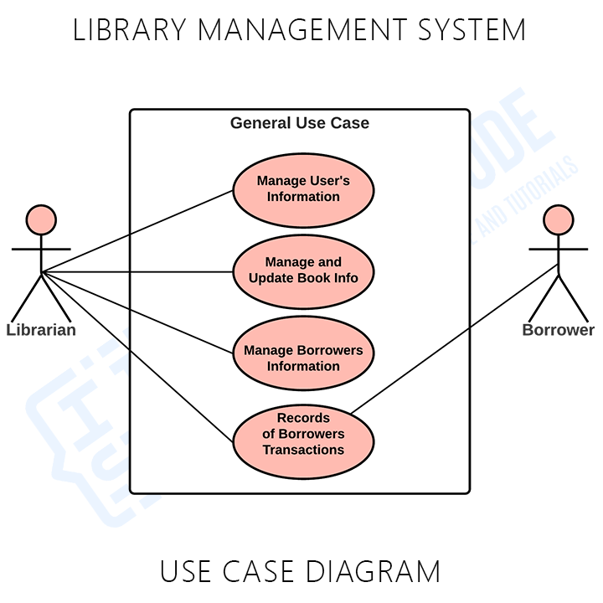

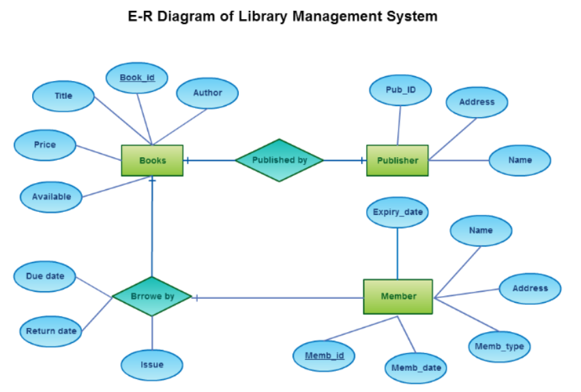

# System Features

## Book Data Management:

5.1.1 Description and Priority: Adding books to LMS is the first most important thing in our project.

5.1.2 Stimulus/Response Sequences: Admin is able to see details of all the books currently present in the database.

5.1.3 Functional Requirements: Admin can add books, delete books and even search for a particular book in database.

## Student Data Management:

5.2.1 Description and Priority: Maintaining details of which student has borrowed which book has second most priority.

5.2.2 Stimulus/Response Sequences: Updates details of which books are issued to which student and book returned details.

5.2.3 Functional Requirements: Admin can see student activity(includes borrowed and returned books info) .

## Modifying Book Details:

5.3.1 Description and Priority: It assumes least priority. It is possible for admin to modify book and student details.

5.3.2 Stimulus/Response Sequences: Details are updated for the action performed (delete, add books etc)

5.3.3 Functional Requirements: It is possible to delete a particular book by its Book Id. In case we need to delete multiple copies of same book, it’s possible in our project.

# 

# Other Non functional Requirements

## Performance Requirements

This project is designed in such a way that the response time for every instruction provided by the admin does not exceed more than 10 seconds.

## Safety Requirements

It is important to check the condition of book after it is returned from a specific user. A student (user) can borrow a book for a maximum of one week. After this duration of 7 days, user must return the book compulsorily.

## Security Requirements

In order to keep details of books and its users safe i.e avoiding some third party to modify the data, only admin is given the login details to the Library Management System.

## Software Quality Attributes

One can easily adapt to the comfortable UI of this software, everything is to the point and precise.

To use this software, No additional knowledge is required.

## Business Rules

The student(user) will be given access to book only if he agrees to return that particular book within 7 days of borrow. No student is given rights to modify LMS. Modification rights are restricted only to Admin (Librarian).

# Other Requirements

This project uses MySQL database.

Appendix A: Glossary

LMS – Library Management System

Appendix B: Field Layouts

An Excel sheet containing field layouts and properties/attributes and report requirements.

**Sample sheet with information required to register the customer**

|  |  |  |  |  |
| --- | --- | --- | --- | --- |
| **Field** | **Length** | **Data Type** | **Description** | **Is Mandatory** |
| Account Number | 16 | Numeric |  | Y |
| ISFC code | 11 | Alphanumeric | | Y |
| Card Amount | 20 | Numeric |  | Y |
| Mandate Start Date | 8 | Date | Date of Mandate Registration | N |
| Mandate End Date | 8 | Date | Date of Mandate Expiry | N |
| Status | 25 | Alphanumeric | Status of Registration | Y |
| Customer Name | 60 | String |  | Y |
| Reject Reason Code | 4 | String | Reject Reason code in case mandate is rejected | N |

**Sample Report Requirements: Include the fields to be included in the report**

|  |  |
| --- | --- |
| **Registration Report** | **Transaction Report** |
|  |  |
| Bank Account Number | Transaction Reference Number |
| ISFC Code | Bank Account Number |
| Bank Name | IFSC Code |
| Account Status | Bank Name |
| Account Type | Customer Name |
| Customer Name | Card Number |
| Card Number | Debit Transaction Amount |
| SI Start Date | Transaction Date |
| Status | Status |
| Remarks | Debit Attempt Number |
|  | Remarks |
|  |  |

Appendix C: Requirement Traceability Matrix

|  |  |  |  |  |  |  |  |
| --- | --- | --- | --- | --- | --- | --- | --- |
| **Sl. No** | **Requirement ID** | **Brief Description of Requirement** | **Architecture Reference** | **Design Reference** | **Code File Reference** | **Test Case ID** | **System Test Case ID** |
|  |  |  |  |  |  |  |  |
|  |  |  |  |  |  |  |  |

https://www.pes.edu/wp-content/uploads/2019/09/pes_logo.png

**B.TECH. (CSE)**

**V SEMESTER**

**UE20303 –SOFTWARE ENGINEERING**

**PROJECT REPORT**

**ON**

LIBRARY MANAGEMENT SYSTEM

SUBMITTED BY

**NAME SRN**

1. **MOHAMMAD SAYEED AKRAM PES2UG20CS201**
2. **NAMAN PANDE PES2UG20CS210**
3. **RAGHAVENDRA M KATAGERI PES2UG20CS261**
4. **PARTH PRAVEEN SHETTY PES2UG20CS240**

**August – Nov 2022**

**DEPARTMENT OF COMPUTER SCIENCE & ENGINEERING**

**BENGALURU – 560100, KARNATAKA, INDIA**